**Software Engineering Tools Lab Assignment No-8**

(Module 5- Software testing using tools)

Q 1. What are the prerequisites for installing the TestLink tool.

Before installing the TestLink tool, you will need to ensure that your system meets the following prerequisites:

Web server: TestLink requires a web server to run. You can use Apache, IIS, or another web server that supports PHP.

PHP: TestLink is written in PHP, so you will need to have PHP installed on your system. The recommended version of PHP is 7.3 or higher.

Database: TestLink requires a database to store test cases and other data. TestLink supports several databases, including MySQL, MariaDB, PostgreSQL, and MS SQL Server.

Database client: You will need to have a client for your chosen database installed on your system. For example, if you are using MySQL, you will need to have the MySQL client installed.

Web browser: TestLink is accessed through a web browser, so you will need to have a web browser installed on your system.

Operating system: TestLink can run on Linux, Windows, or Mac OS X. You will need to have a supported operating system installed on your system.

Permissions: You will need to have permission to install and configure software on your system. If you are installing TestLink on a shared server, you may need to contact your system administrator to obtain the necessary permissions.

By ensuring that your system meets these prerequisites, you can proceed with the installation of the TestLink tool.

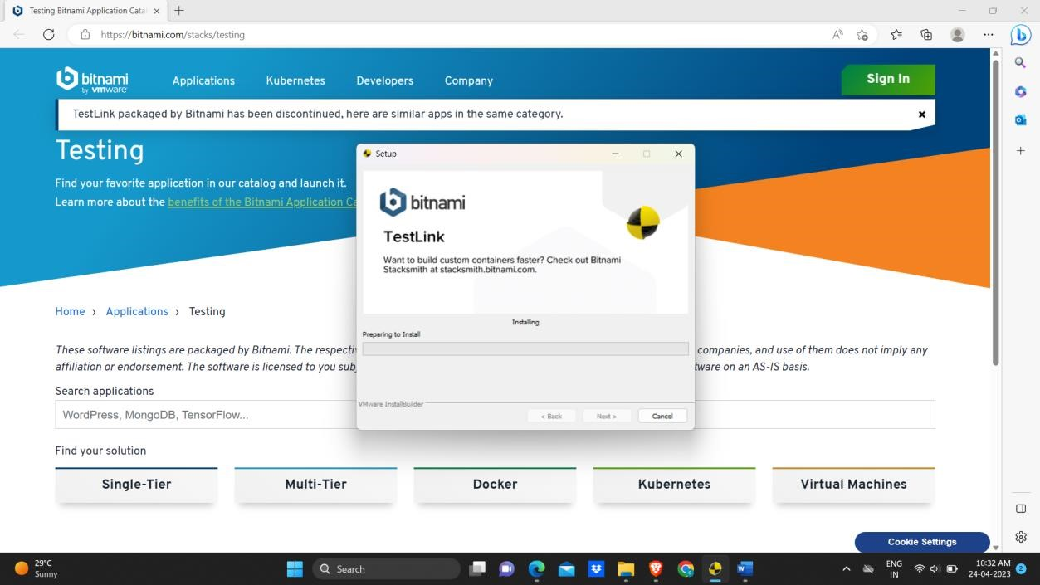Q 2. Install TestLink tool on your machine (Provide screen shots for successful installation and login)

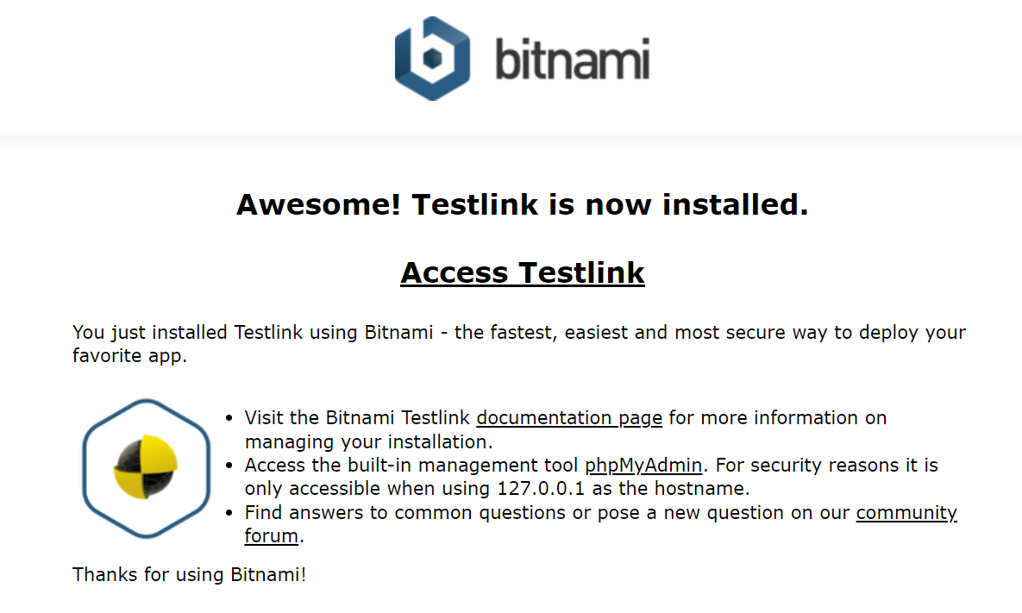

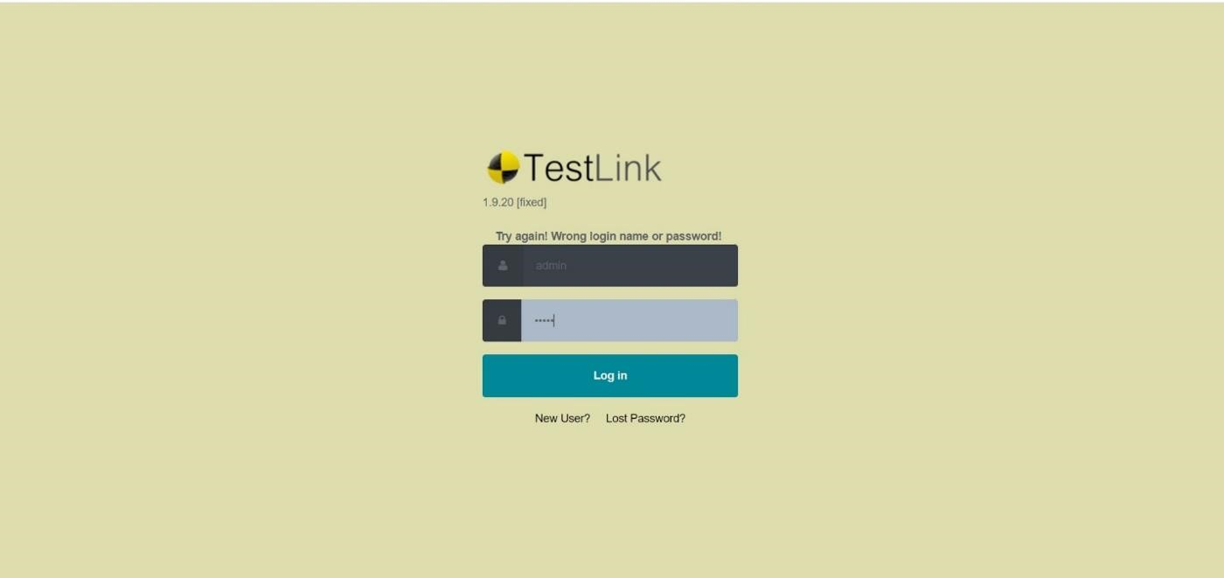

Q 3. Using TestLink tool create multiple test cases (at least 10) on any application/project that you have implemented.

Perform below tasks

1. Create New test project as SETProject

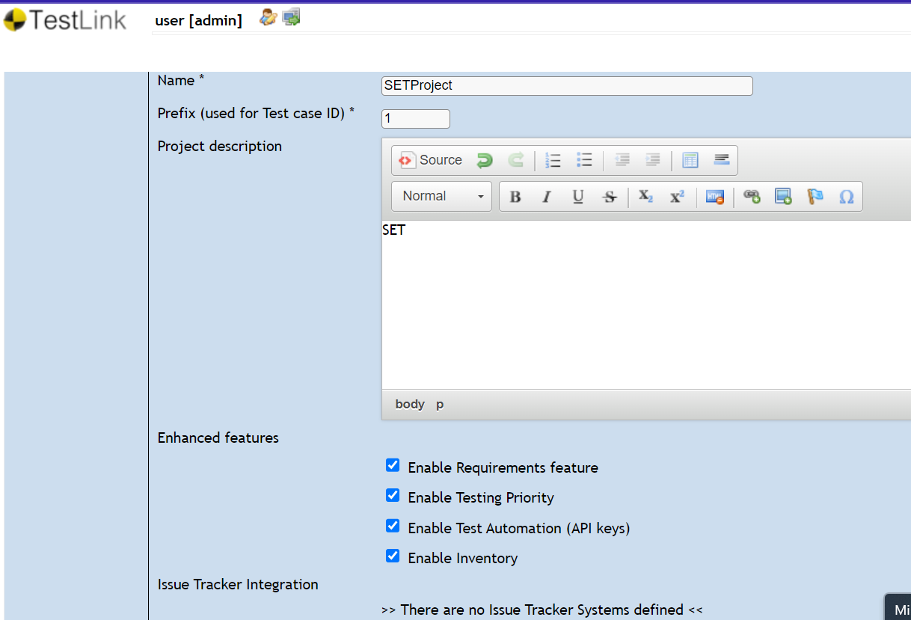

1. Create a test plan as SETProjectTestPlan

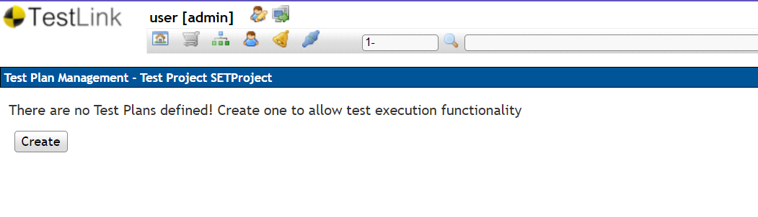

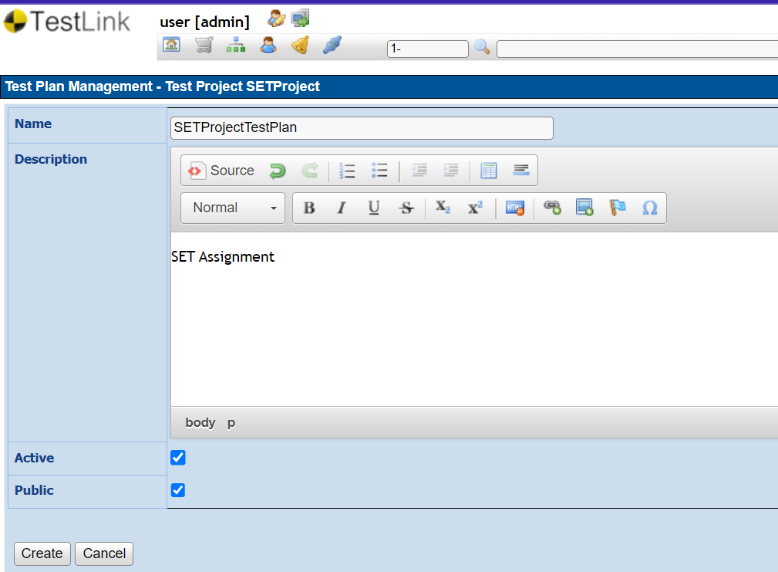

1. Create a build as SETProjectBuild

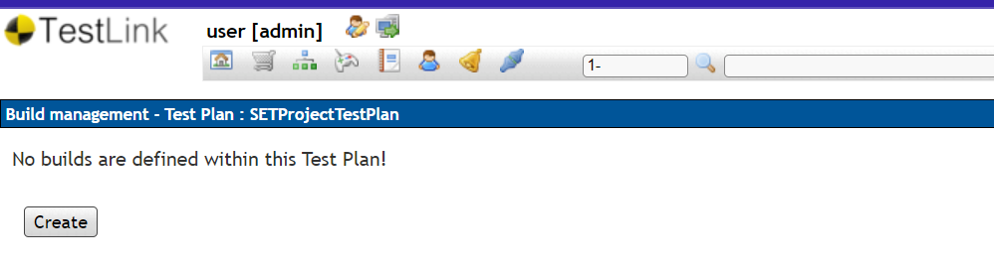

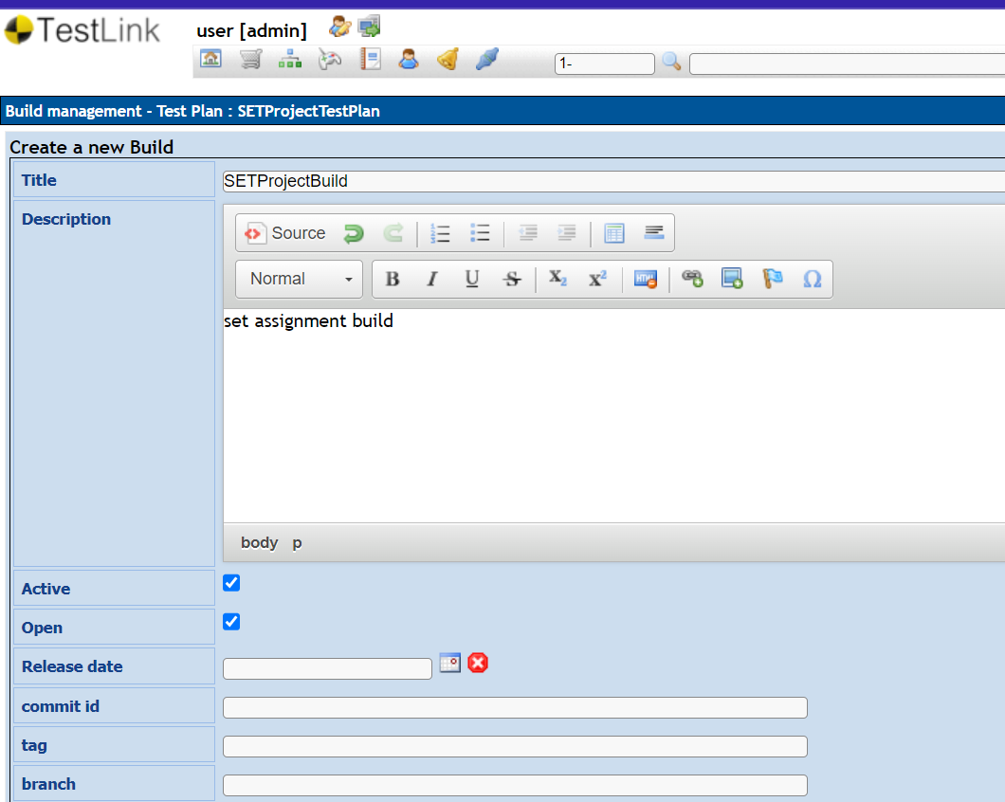

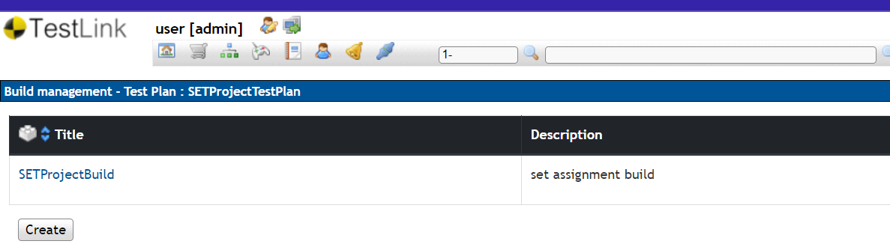

1. Create test suite as Test Suite 1 under SETProject

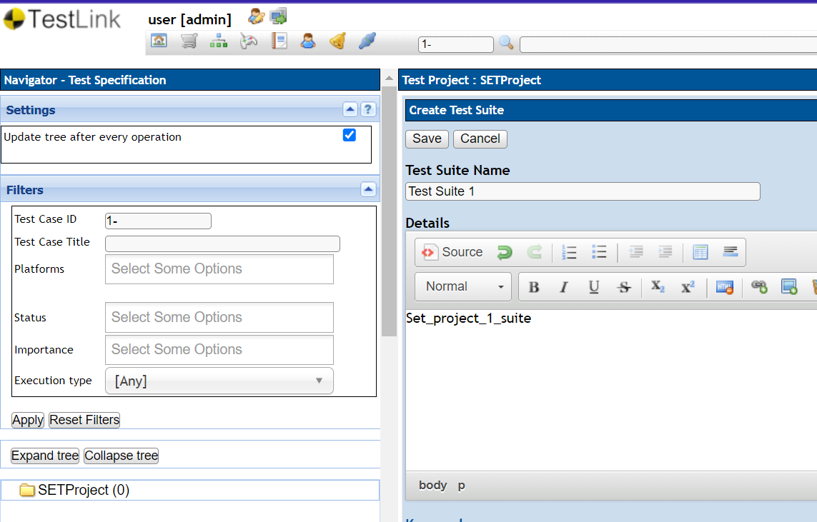

1. Create Test cases in TestLink Tool

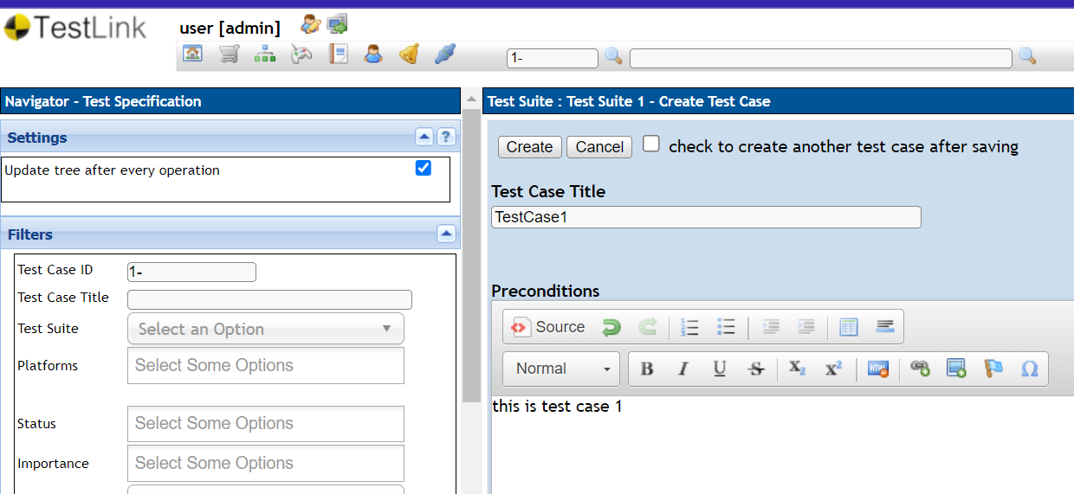

1. Assign created Test Cases to the test plan SETProjectTestPlan

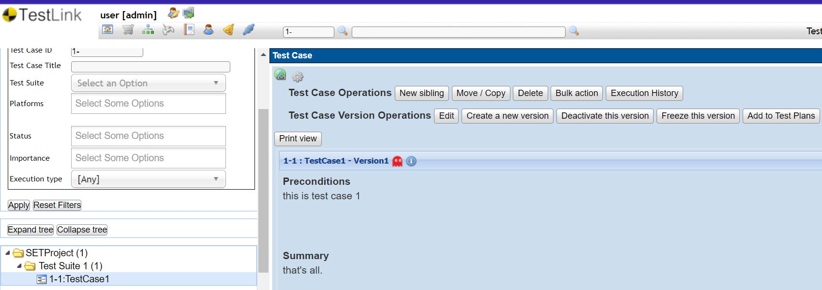

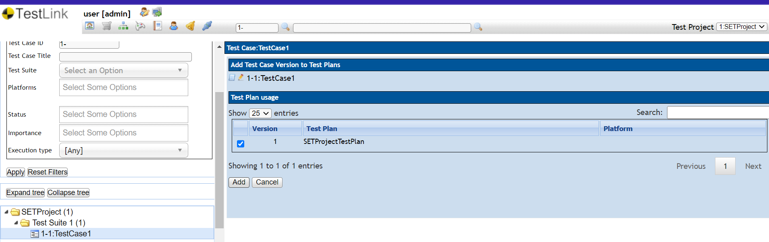

1. Create different roles as given below in the TestLink

|  |  |  |  |
| --- | --- | --- | --- |
| **S No.** | **Role** | **Test Cases** | **Test Metrics** |
|  |  |  |  |
| 1. | Guest | View | View |
| 2. | Tester | Execute | View |
|  |  |  |  |
| 3. | Senior Tester | Edit & Execute | View |
|  |  |  |  |
| 4. | Leader & Admin | Edit & Execute | Edit & Execute |

Guest -

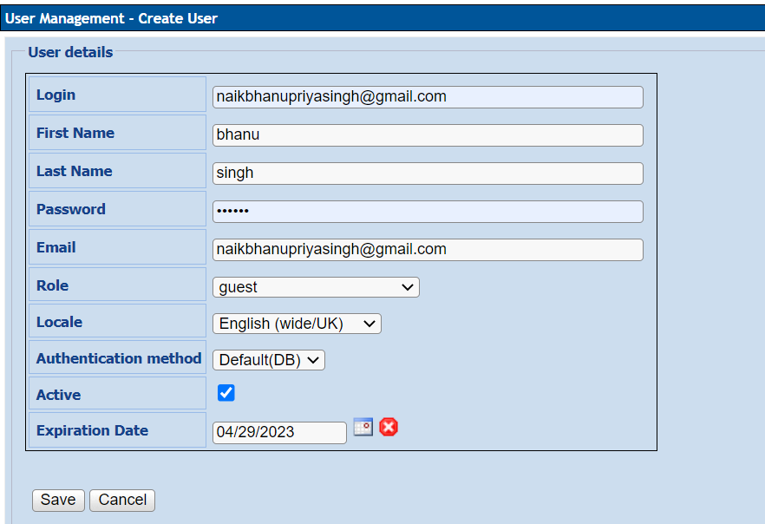

Tester –

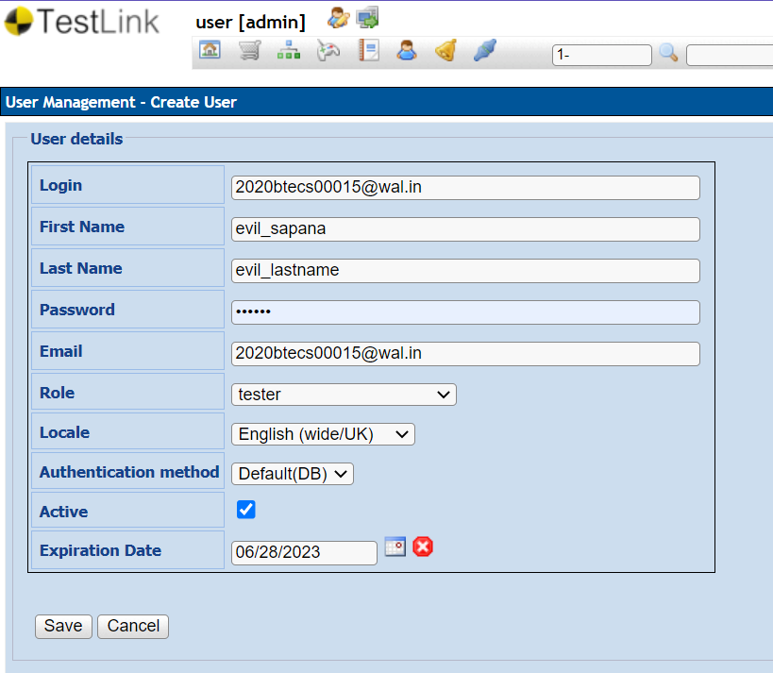

Senior Tester –

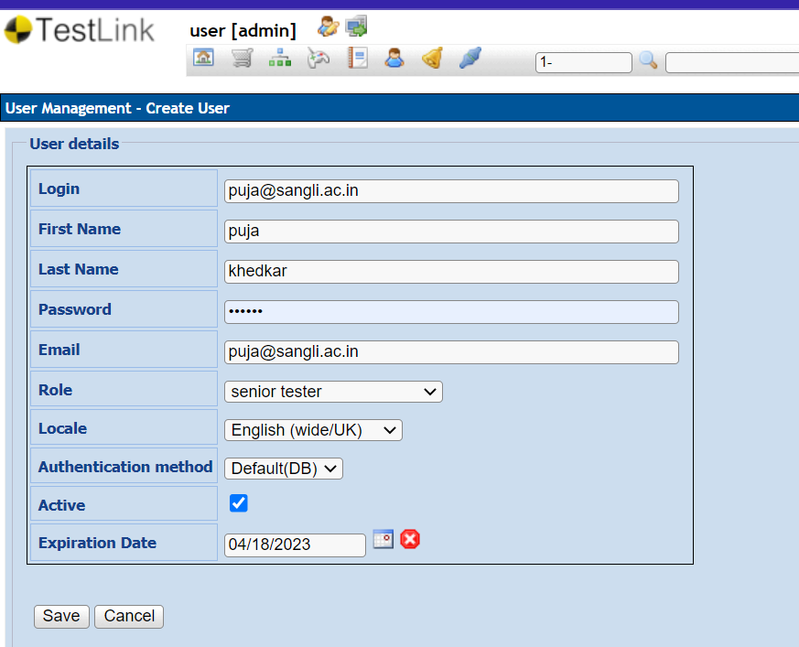

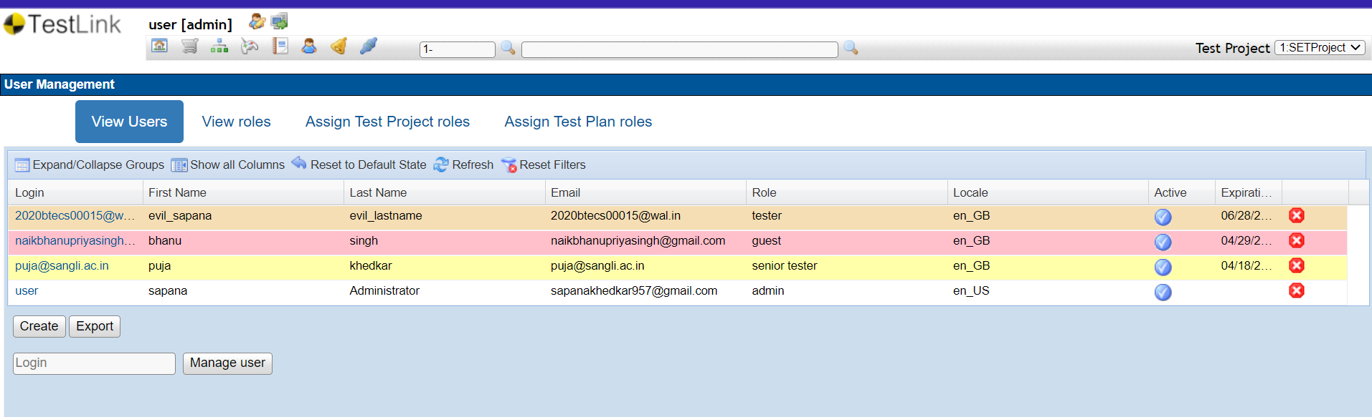

1. Write a requirements in TestLink

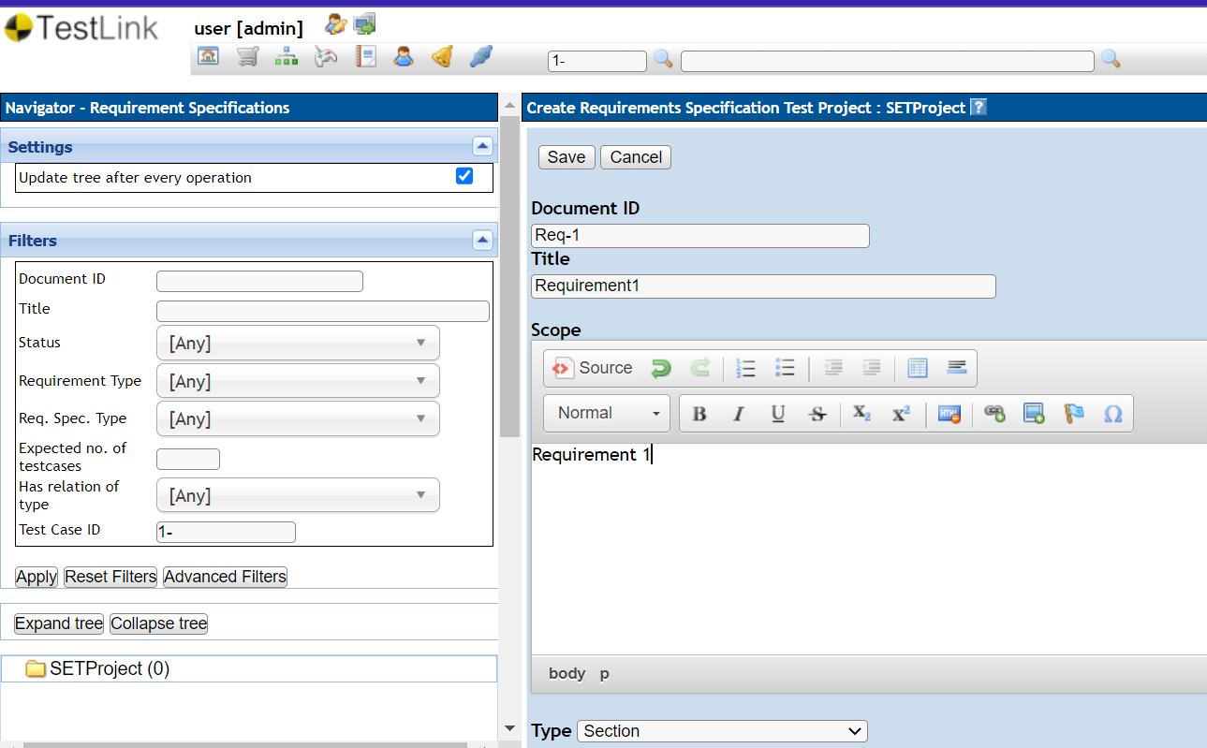

1. Execute test cases

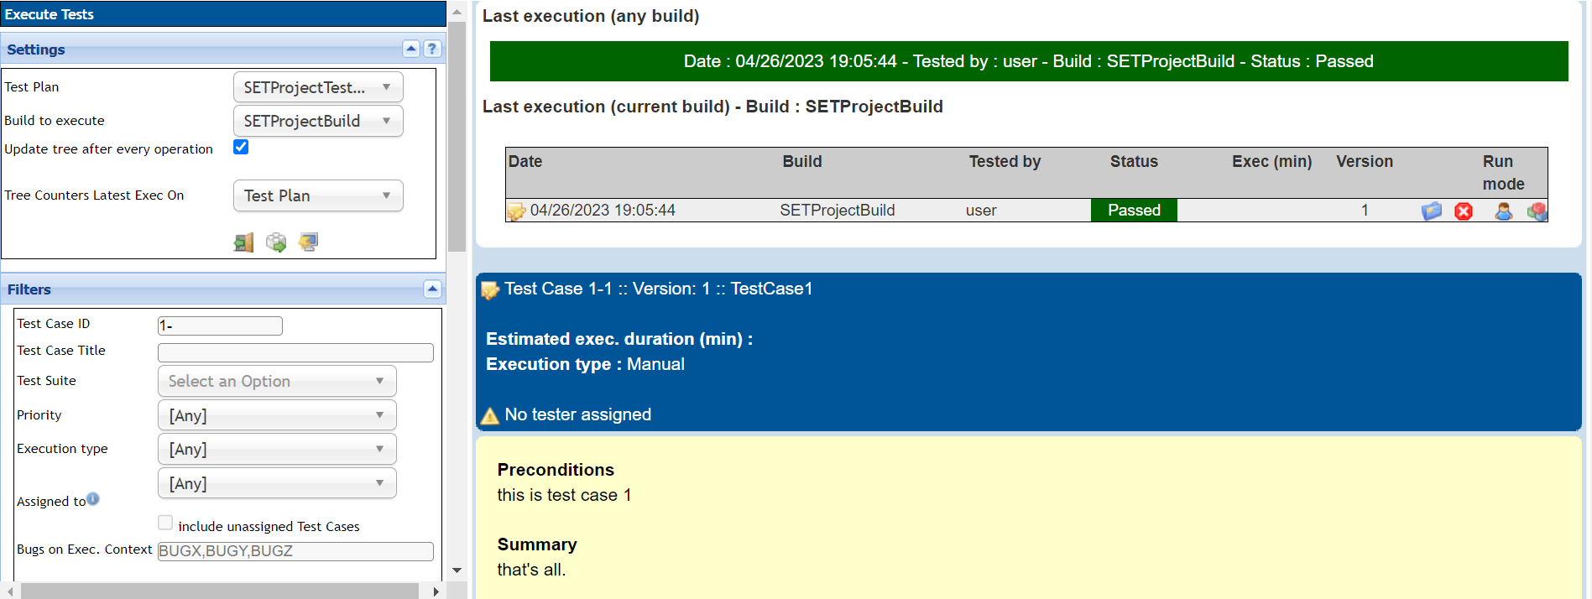

1. Generate a test report in excel format.

